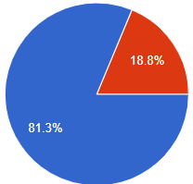

***In question two, 81.3% of people chose democratic this shows that people are more willing to cooperate with each other while working on team project. While only 18.8% of people chose autocratic.***



***In question 7, 81.3% of people chose that study groups enhance undergraduates’ school/ university performance, which further proves that more people believe that cooperation leads to the best results. While only 18.8% disagree with that statement.***